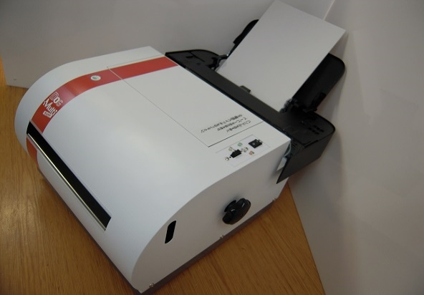
New Product Release!
Braille Printer
DOG Multi ADF
New Released DOG Multi ADF
We are happy to announce a new Braille printer, ‘DOG ADF’, one of our quiet Braille printer series, using a new Auto Document Feeder.
DOG Multi ADF can print on normal A4 sized Single-sheet paper.
It can print Braille and ink simultaneously at minimum noise. They are popular because you do not need to know Braille to understand what has been printed. This has led to the wide spread use in schools, local government and financial organizations.

・You can keep 80 A4 sized shingle sheets in the paper tray.
・You can choose either just Braille or both ink and Braille printing. It is as easy as other ink jet printing.
・The printing sound is extremely quiet , you can use it in your classroom.
・It supports multi world languages. (using DBT software）
Nippon Telesoft Co.,Ltd.
E-mail ts-info@telesoft.co.jp
Http://www.nippontelesoft.com

